HTML QUICK STYLER
Project Work Report
Submitted to Alagappa University in partial
Fulfilment of the requirement for the award of the
Degree in Bachelor of Computer Science
Submitted By
TEAM ID: SWTID-2026-6959
TEAM LEADER:
Monisha S (Reg.No.2523128006)
TEAM MEMBERS
Punitha B (Reg.No.2523128007)
Sana Fathima A (Reg.No.2523128008)
DHIVYA THARSHINI M (Reg.No.2523128003)
Under the Naan Mudhalvan Incharge of
Mrs. C. AMIRTHARANI MCA., M.Phil.,

DEPARTMENT OF COMPUTER SCIENCE
CAUSSANEL COLLEGE OF ARTS AND SCIENCE
Accredited With ‘A’ Grade by NAAC
Recognized by UGC Under 2(f) &12(B)
(Co-Education)
(Affiliated to Alagappa University)
Muthupettai-623523
April-2026

S.NO | CONTENTS
 | ABSTRACT
 | INTRODUCTION
 | - Project Overview
 | - Problem Statement
 | 2.3 Objectivities
 | 2.4 Scope of Project
 | SYSTEM ANALYSIS
 | - Feasibility Study (Technical, Economic, Operational)
 | 3. Hardware and Software Requirements
 | 3.3 Existing System vs. Proposed System
 | SYSTEM DESIGN
 | 5.1 System Architecture
 | 5.2 Data Flow Diagram
 | 5.3 Use Case Diagrams
 | 5.4 User Interface Design (UI/UX)
 | SYSTEM IMPLEMENTATION
 | 6.1 File Structure
 | 6.2 HTML Code (Structure)
 | 6.3 CSS Code (Styling)
 | 6.4 JavaScript Code (Logic)
 | TESTING AND SCREENSHOTS
 | 7. Testing Methodologies
 | 7.2 Test Cases
 | 7.3 Output Screenshots
 | CONCLUSION & FUTURE ENHANCEMENT
INTRODUCTION
1.1 Overview
The HTML Quick Styler is a web-based development tool designed to bridge the gap between coding structure (HTML) and visual styling (CSS). In the modern web development landscape, beginners often struggle to visualize how CSS properties affect HTML elements in real-time. This project provides a "What You See Is What You Get" (WYSIWYG) styling environment.
Users can write raw HTML in a dedicated editor and use a graphical user interface (GUI) side-panel to adjust CSS properties such as colors, fonts, borders, and padding. The system generates the corresponding CSS code automatically, which can be copied and used in production websites.
1.2 Problem Statement
Learning web development involves understanding the separation of concerns: HTML for structure and CSS for style. Beginners often face the following challenges:
- Context Switching: Constantly switching between a code editor and a browser to see changes.
- Syntax Errors: Typing complex CSS rules manually leads to syntax errors.
- Visualization: Difficulty understanding how numerical values (like padding: 20px vs 30px) affect layout visually.
1.3 Objectives
The primary objectives of this project are:
- To create a real-time environment where HTML renders immediately.
- To provide a GUI for manipulating CSS properties without writing code.
- To generate clean, valid CSS code that the user can export.
- To create a responsive and intuitive user interface using modern web standards.
1.4 Scope
- Target Audience: Students, beginner web developers, and UI designers prototyping simple components.
- Platform: The application runs in any modern web browser (Chrome, Firefox, Edge, Safari) without installation.
- Functionality: Covers basic to intermediate CSS properties (Typography, Box Model, Colors, Borders).
SYSTEM ANALYSIS
2.1 Feasibility Study

Technical Feasibility

The project uses standard web technologies (HTML, CSS, JS). No special hardware or server-side languages (like PHP or Python) are required. The complexity is low to medium, focusing heavily on DOM manipulation. Therefore, it is technically feasible.

Economic Feasibility

The project is cost-effective. It requires no paid licenses, no cloud hosting costs (can run locally), and uses open-source libraries (FontAwesome). The development cost is limited to time and effort.

Operational Feasibility

The system is intuitive. Users familiar with basic computer operations can use the sliders and buttons. No special training is required.

2.2 Hardware and Software Requirements

Hardware:

- Processor: Dual Core or higher.
- RAM: 2GB or higher.
- Hard Disk: 100MB free space.

Software:

- Operating System: Windows 10/11, macOS, or Linux.
- Code Editor: VS Code, Notepad++, or Sublime Text.
- Browser: Google Chrome (Recommended).

2.3 Existing vs. Proposed System

Existing System:
Developers write code in an IDE, save the file, switch to a browser, and refresh the page. If the style is wrong, they repeat the loop.

Proposed System (HTML Quick Styler):
Developers type HTML in one pane and adjust sliders in another. The result updates instantly. The CSS code is auto-generated at the end of the session.

SYSTEM DESIGN
3.1 System Architecture

The application follows a Client-Side Event-Driven Architecture.

- Input Layer: User interacts with the Textarea (HTML) and Inputs (Range sliders, Color pickers).
- Logic Layer (JavaScript): Event listeners detect changes. Functions update the DOM properties of the preview element.
- Presentation Layer: The browser renders the updated styles immediately.

3.2 Data Flow Diagram (DFD)

- Level 0 DFD: User -> Input Data -> [System] -> Output Preview & CSS Code.
- Level 1 DFD:
  - Input HTML -> Update InnerHTML -> Preview Screen.
  - Input Slider -> JS Event -> Update Style Attribute -> Preview Screen.
  - Click Export -> Read Style Object -> Format String -> Modal Popup.

3.3 User Interface Design

The UI is divided into three main sections (Flexbox Layout):

- Header: Title and "Get CSS" button.
- Sidebar (Left): Controls for Color, Font Size, Padding, Radius, Alignment.
- Workspace (Right): Split vertically between the HTML Editor and the Live Preview.

IMPLEMENTATION

4.1 File Structure
The project consists of three core files:
- index.html: The main entry point.
- style.css: The visual theme of the application.
- script.js: The functional logic.
4.2 HTML Code (index.html)
The HTML file utilizes semantic tags. It includes a Sidebar aside for controls and a section for the workspace.

<!DOCTYPE html>
<html lang="en">
<head>
<meta charset="UTF-8">
<meta name="viewport" content="width=device-width, initial-scale=1.0">
<title>HTML Quick Styler</title>
<link rel="stylesheet" href="style.css">
<!-- FontAwesome for Icons -->
<link rel="stylesheet" href="https://cdnjs.cloudflare.com/ajax/libs/font-awesome/6.0.0/css/all.min.css">
</head>
<body>

<header>
<h1><i class="fas fa-paint-brush"></i> HTML Quick Styler</h1>
<button id="get-css-btn" class="btn-primary">Get CSS Code</button>
</header>

<div class="main-container">
<!-- Sidebar Controls -->
<aside class="controls">
<h3>Style Controls</h3>

<div class="control-group">
<label>Text Color</label>
<input type="color" id="color-picker" value="#000000">
</div>

<div class="control-group">
<label>Background Color</label>
<input type="color" id="bg-color-picker" value="#ffffff">
</div>

<div class="control-group">
<label>Font Size (<span id="fs-val">16</span>px)</label>
<input type="range" id="font-size" min="10" max="100" value="16">
</div>

<div class="control-group">
<label>Padding (<span id="pd-val">10</span>px)</label>
<input type="range" id="padding" min="0" max="100" value="10">
</div>

<div class="control-group">
<label>Border Radius (<span id="br-val">0</span>px)</label>
<input type="range" id="border-radius" min="0" max="50" value="0">
</div>

<div class="control-group">
<label>Text Align</label>
<div class="btn-group">
<button data-style="textAlign" data-value="left"><i class="fas fa-align-left"></i></button>
<button data-style="textAlign" data-value="center"><i class="fas fa-align-center"></i></button>
<button data-style="textAlign" data-value="right"><i class="fas fa-align-right"></i></button>
</div>
</div>

<div class="control-group">
<label>Font Style</label>
<div class="btn-group">
<button id="bold-btn"><i class="fas fa-bold"></i></button>
<button id="italic-btn"><i class="fas fa-italic"></i></button>
</div>
</div>
</aside>

<!-- Editor and Preview Area -->
<section class="workspace">
<div class="editor-box">
<div class="label">HTML Input</div>
<textarea id="html-input" placeholder="Type your HTML here..."><h1>Hello World</h1>
<p>This is a quick styler demo.</p>
<button>Click Me</button></textarea>
</div>

<div class="preview-box">
<div class="label">Live Preview</div>
<div id="preview-screen">
<!-- Content renders here -->
</div>
</div>
</section>
</div>

<!-- Modal for CSS Output -->
<div id="css-modal" class="modal">
<div class="modal-content">
<span class="close">&times;</span>
<h2>Generated CSS</h2>
<textarea id="css-output" readonly></textarea>
<button id="copy-btn">Copy to Clipboard</button>
</div>
</div>

<script src="script.js"></script>
</body>
</html>
4.3 CSS Code (style.css)
The CSS uses CSS Variables (:root) for easy theme management. It employs flexbox to ensure the sidebar and workspace sit side-by-side on large screens.

:root {
--primary: #4a90e2;
--dark: #333;
--light: #f4f4f4;
--border: #ddd;
}

* {
box-sizing: border-box;
margin: 0;
padding: 0;
font-family: 'Segoe UI', Tahoma, Geneva, Verdana, sans-serif;
}

body {
background-color: #eef1f5;
height: 100vh;
display: flex;
flex-direction: column;
}

header {
background-color: var(--dark);
color: white;
padding: 1rem 2rem;
display: flex;
justify-content: space-between;
align-items: center;
}

.btn-primary {
background: var(--primary);
color: white;
border: none;
padding: 8px 16px;
border-radius: 4px;
cursor: pointer;
font-weight: bold;
}

.btn-primary:hover {
background: #357abd;
}

.main-container {
display: flex;
flex: 1;
overflow: hidden;
}

/* Sidebar Controls */
.controls {
width: 300px;
background: white;
border-right: 1px solid var(--border);
padding: 20px;
overflow-y: auto;
}

.controls h3 {
margin-bottom: 20px;
color: var(--dark);
border-bottom: 2px solid var(--primary);
padding-bottom: 5px;
}

.control-group {
margin-bottom: 20px;
}

.control-group label {
display: block;
margin-bottom: 8px;
font-weight: 600;
font-size: 0.9rem;
color: #555;
}

input[type="color"] {
width: 100%;
height: 40px;
border: 1px solid var(--border);
cursor: pointer;
}

input[type="range"] {
width: 100%;
cursor: pointer;
}

.btn-group {
display: flex;
gap: 5px;
}

.btn-group button {
flex: 1;
padding: 8px;
border: 1px solid var(--border);
background: #f9f9f9;
cursor: pointer;
border-radius: 4px;
}

.btn-group button:hover {
background: #e2e2e2;
}

/* Workspace */
.workspace {
flex: 1;
display: flex;
flex-direction: column;
padding: 20px;
gap: 20px;
}

.editor-box, .preview-box {
flex: 1;
background: white;
border: 1px solid var(--border);
border-radius: 8px;
display: flex;
flex-direction: column;
overflow: hidden;
box-shadow: 0 2px 5px rgba(0,0,0,0.05);
}

.label {
background: #f0f0f0;
padding: 8px 15px;
font-size: 0.85rem;
font-weight: bold;
color: #666;
border-bottom: 1px solid var(--border);
}

textarea#html-input {
flex: 1;
border: none;
padding: 15px;
font-family: 'Courier New', monospace;
font-size: 14px;
resize: none;
outline: none;
background: #282c34;
color: #abb2bf;
}

#preview-screen {
flex: 1;
padding: 20px;
overflow: auto;
transition: all 0.3s ease;
}

/* Modal */
.modal {
display: none;
position: fixed;
z-index: 100;
left: 0;
top: 0;
width: 100%;
height: 100%;
background-color: rgba(0,0,0,0.5);
align-items: center;
justify-content: center;
}

.modal-content {
background: white;
padding: 20px;
border-radius: 8px;
width: 500px;
position: relative;
}

.close {
position: absolute;
right: 20px;
top: 10px;
font-size: 28px;
cursor: pointer;
}

#css-output {
width: 100%;
height: 150px;
margin: 15px 0;
padding: 10px;
background: #f4f4f4;
border: 1px solid var(--border);
}

#copy-btn {
width: 100%;
padding: 10px;
background: var(--dark);
color: white;
border: none;
cursor: pointer;
}

4.4 JavaScript Code (script.js)
The script uses addEventListener to listen for 'input' events on sliders. This ensures real-time updates (as opposed to 'change' events which only update after letting go of the mouse).

document.addEventListener('DOMContentLoaded', () => {
// --- Elements ---
const htmlInput = document.getElementById('html-input');
const previewScreen = document.getElementById('preview-screen');

// --- Control Inputs ---
const colorPicker = document.getElementById('color-picker');
const bgColorPicker = document.getElementById('bg-color-picker');
const fontSize = document.getElementById('font-size');
const padding = document.getElementById('padding');
const borderRadius = document.getElementById('border-radius');
const alignButtons = document.querySelectorAll('button[data-style="textAlign"]');
const boldBtn = document.getElementById('bold-btn');
const italicBtn = document.getElementById('italic-btn');

// --- Labels for Values ---
const fsVal = document.getElementById('fs-val');
const pdVal = document.getElementById('pd-val');
const brVal = document.getElementById('br-val');

// --- CSS Modal Elements ---
const modal = document.getElementById('css-modal');
const getCssBtn = document.getElementById('get-css-btn');
const closeBtn = document.querySelector('.close');
const cssOutput = document.getElementById('css-output');
const copyBtn = document.getElementById('copy-btn');

// --- State Variables ---
let isBold = false;
let isItalic = false;

// 1. Function: Render HTML to Preview
function updateHTML() {
previewScreen.innerHTML = htmlInput.value;
}

// 2. Function: Update Visual Styles
function updateStyles() {
// Apply styles to the preview container
previewScreen.style.color = colorPicker.value;
previewScreen.style.backgroundColor = bgColorPicker.value;
previewScreen.style.fontSize = `${fontSize.value}px`;
previewScreen.style.padding = `${padding.value}px`;
previewScreen.style.borderRadius = `${borderRadius.value}px`;

// Update the text numbers next to sliders
fsVal.textContent = fontSize.value;
pdVal.textContent = padding.value;
brVal.textContent = borderRadius.value;
}

// --- Event Listeners ---

// Real-time updates
htmlInput.addEventListener('input', updateHTML);
colorPicker.addEventListener('input', updateStyles);
bgColorPicker.addEventListener('input', updateStyles);
fontSize.addEventListener('input', updateStyles);
padding.addEventListener('input', updateStyles);
borderRadius.addEventListener('input', updateStyles);

// Text Alignment Buttons
alignButtons.forEach(btn => {
btn.addEventListener('click', () => {
// Remove active class from all
alignButtons.forEach(b => b.style.background = '#f9f9f9');
// Add active style to clicked
btn.style.background = '#ccc';
previewScreen.style.textAlign = btn.getAttribute('data-value');
});
});

// Bold Button Logic
boldBtn.addEventListener('click', () => {
isBold = !isBold;
previewScreen.style.fontWeight = isBold ? 'bold' : 'normal';
boldBtn.style.background = isBold ? '#ccc' : '#f9f9f9';
});

// Italic Button Logic
italicBtn.addEventListener('click', () => {
isItalic = !isItalic;
previewScreen.style.fontStyle = isItalic ? 'italic' : 'normal';
italicBtn.style.background = isItalic ? '#ccc' : '#f9f9f9';
});

// --- CSS Generation & Export ---

getCssBtn.addEventListener('click', () => {
const styles = `
.styled-content {
color: ${colorPicker.value};
background-color: ${bgColorPicker.value};
font-size: ${fontSize.value}px;
padding: ${padding.value}px;
border-radius: ${borderRadius.value}px;
text-align: ${previewScreen.style.textAlign || 'left'};
font-weight: ${isBold ? 'bold' : 'normal'};
font-style: ${isItalic ? 'italic' : 'normal'};
}`;
cssOutput.value = styles.trim();
modal.style.display = 'flex';
});

// Close Modal Logic
closeBtn.addEventListener('click', () => modal.style.display = 'none');
window.onclick = (event) => {
if (event.target == modal) modal.style.display = "none";
};

// Copy to Clipboard (Modern Method)
copyBtn.addEventListener('click', async () => {
try {
await navigator.clipboard.writeText(cssOutput.value);
const originalText = copyBtn.textContent;
copyBtn.textContent = 'Copied!';
copyBtn.style.background = '#28a745'; // Green color

setTimeout(() => {
copyBtn.textContent = originalText;
copyBtn.style.background = '#333'; // Reset color
}, 2000);
} catch (err) {
alert('Failed to copy text: ' + err);
}
});

// Initialize on Load
updateHTML();
updateStyles();
});

TESTING & OUTPUT
5.1 Testing Methodology

We utilized Unit Testing and Manual Black Box Testing. Each control (slider/button) was tested individually to ensure it modifies the correct CSS property.

5.2 Test Cases

Test Case ID | Test Scenario | Input Data | Expected Result | Status
TC-01 | Change Text Color | Select Red (#FF0000) | Preview text turns Red | Pass
TC-02 | Adjust Font Size | Slide to 24px | Text size increases | Pass
TC-03 | HTML Injection | Type <h1>Hi</h1> | Header renders in Preview | Pass
TC-04 | Border Radius | Slide to 20px | Box corners become rounded | Pass
TC-05 | Export CSS | Click "Get CSS" | Modal opens with valid CSS | Pass
TC-06 | Copy to Clipboard | Click Copy Button | Text copied to clipboard | Pass

5.3 Screenshots

Figure 1: The Main Dashboard
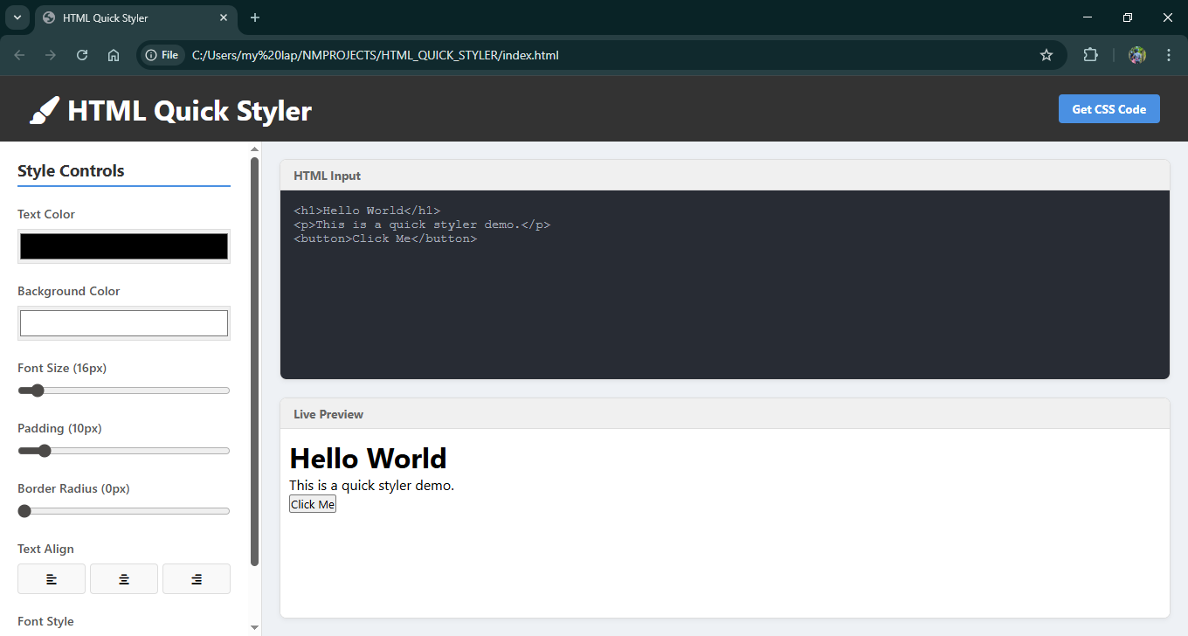

Figure 2: Changing Background and Text Color
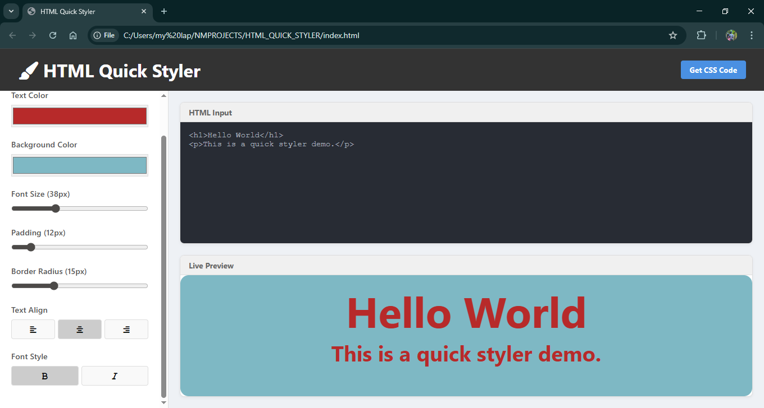

Figure 3: CSS Output Modal
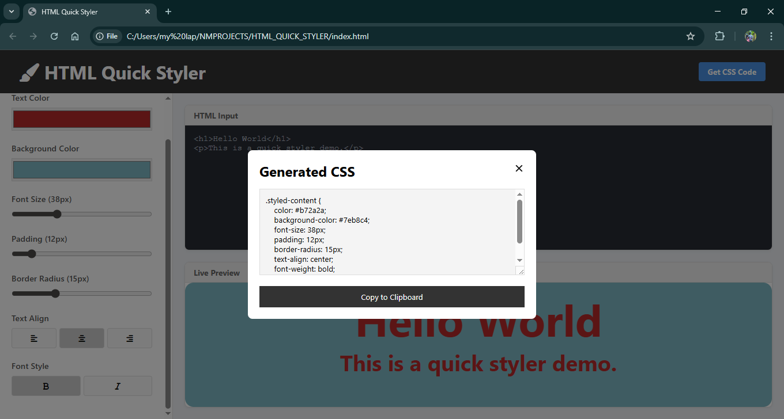

CONCLUSION
6.1 Conclusion
The HTML Quick Styler project successfully achieves its goal of simplifying the web design process for beginners. By abstracting the complexity of CSS syntax into a visual interface, it allows users to focus on design aesthetics. The application works seamlessly across browsers and requires no installation. It demonstrates the power of modern JavaScript in manipulating the DOM in real-time.
6.2 Future Enhancements
While the current version is functional, several features could be added in the future:
- Multiple Elements: Allow styling of specific classes rather than the whole container.
- Save Projects: Use LocalStorage or a Database to save work and return later.
- More CSS Properties: Add Box Shadow, Flexbox controls, and Grid controls.
- Syntax Highlighting: Integrate a library like CodeMirror for the HTML input box.
6.3 Bibliography / References
- MDN Web Docs (Mozilla Developer Network) - developer.mozilla.org
- W3Schools HTML & CSS Tutorials - w3schools.com
- FontAwesome Icon Documentation - fontawesome.com
- StackOverflow Community Forums.

